# **Department of Computer Science and Engineering Islamic University of Technology (IUT)** A subsidiary organ of OIC

# **Lab Report 03**

# CSE 4412: Data Communication and Networking Lab

## 

## **Name: Namisa Najah Raisa Student ID: 210042112 Section: B(Even) Semester: 4th(Summer) Academic Year: 2022-2023**

**Date of Submission: February 10, 2024**

### **Title:** Understanding the basics of Variable Length Subnet Mask (VLSM) and VLANs and Inter-VLAN communication

### **Objectives**:

1. Define and describe the concept of VLAN
2. Describe the advantages of VLAN
3. Design and implement Inter-VLAN routing
4. Understand and implement VLSM

### **Diagram of the experiment:**

(Provide screenshot of the final network topology. Make sure to label the network components.)

**TASK #01:**

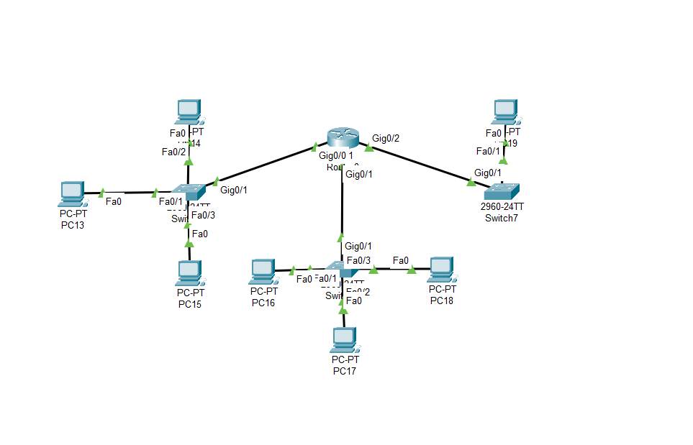

**TASK #02:**

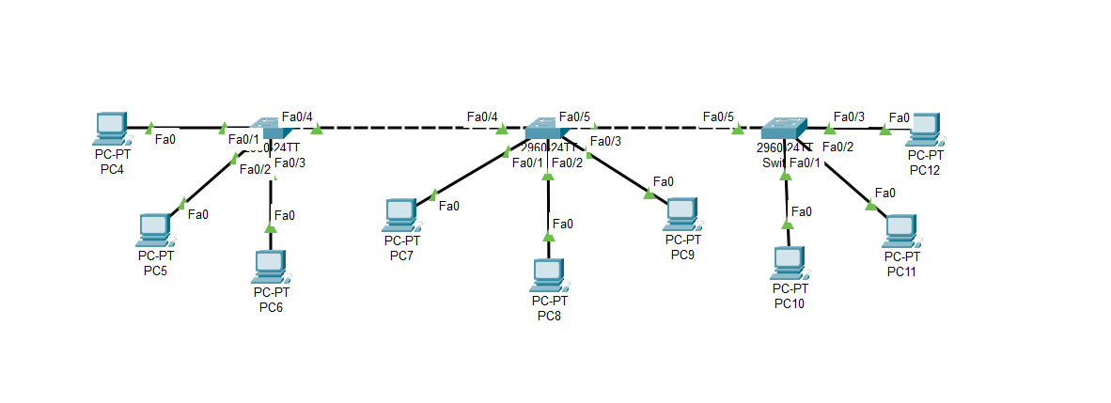

### **Working Procedure:**

**(**Explain in brief how you completed the tasks. Provide necessary screenshots of used commands for each task.)

**TASK #01:**

For adding another network to the existing topology, I gave the following commands as shown in the screenshot.

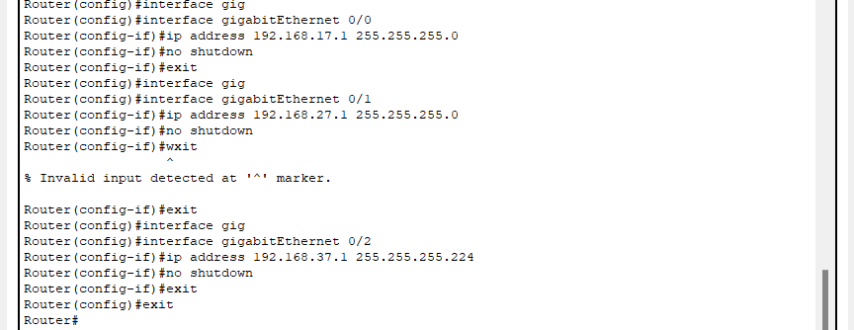

From a PC in the first network to the PC of the new network:

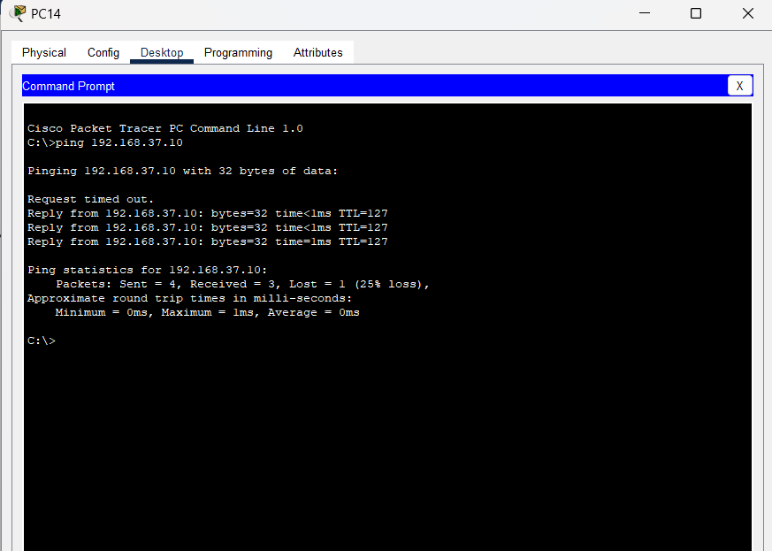

From a PC in the second network to the PC in the new network:

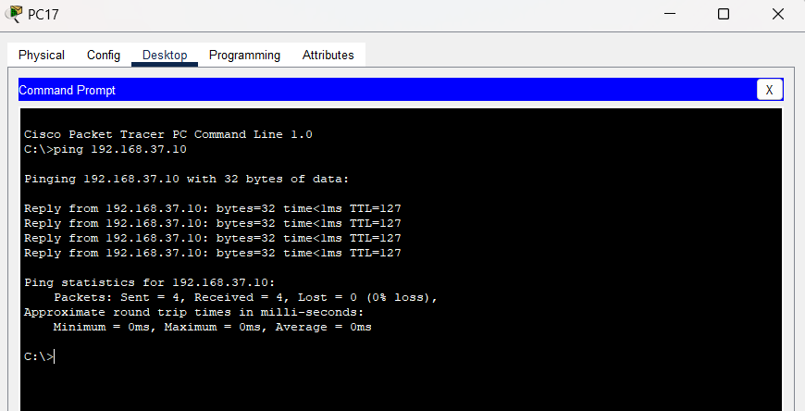

From a PC in the new network to PCs in the first and second network:

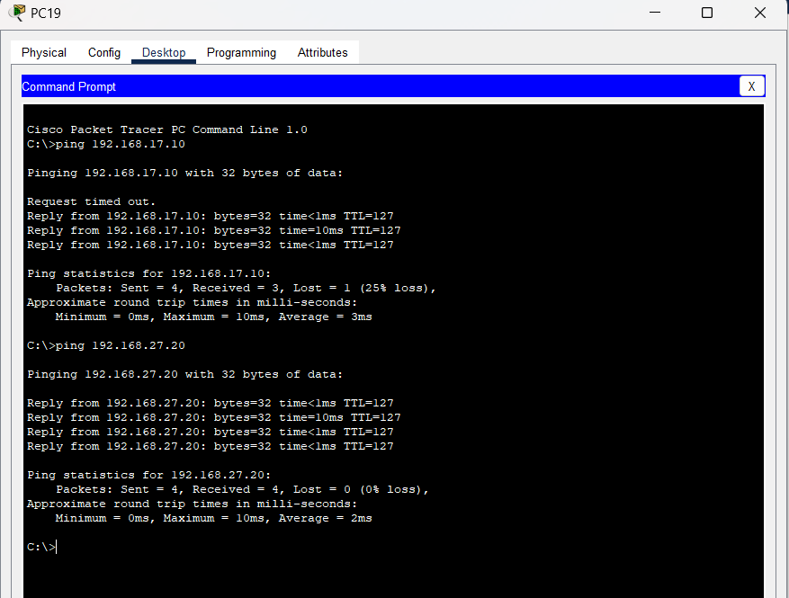

**TASK #02:**

**For switch2:**

First I configured the switch for the three VLANs and gave them names according to the given instructions. Then to allow access for communication I used the commands :  
#interface Fast-Ethernet 0/4

#switchport mode trunk

(this command configures the interface as a trunk link)

#switchport trunk allowed vlan all.

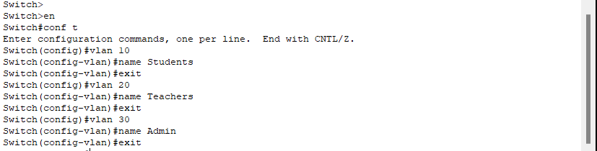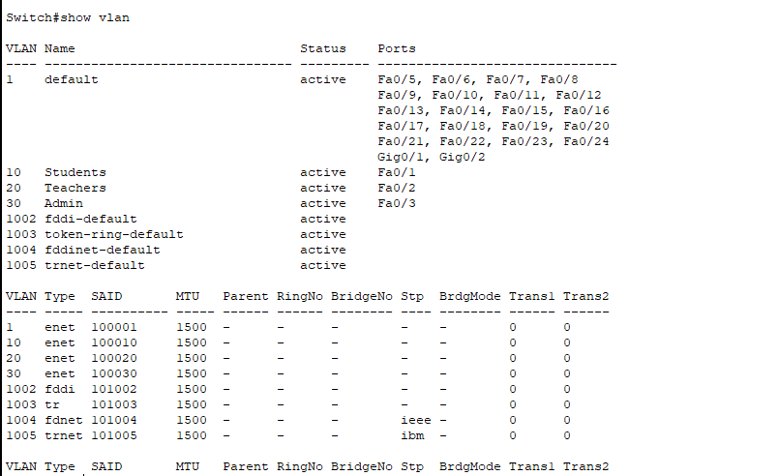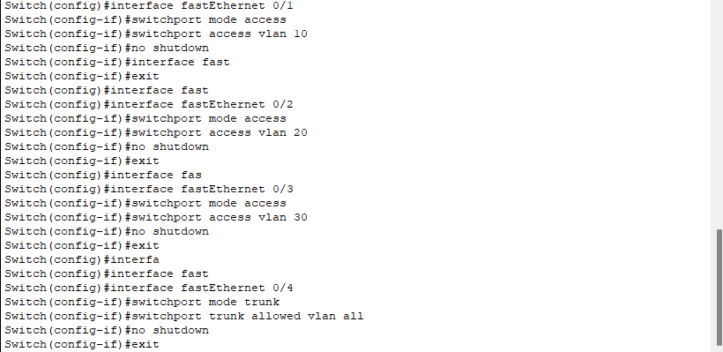

**For Switch 3:**

Same as switch 2.

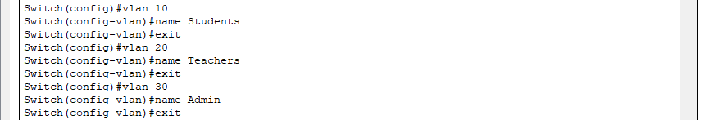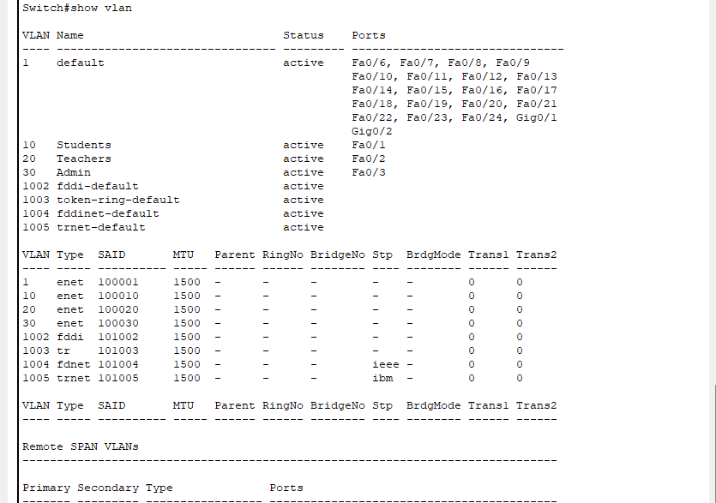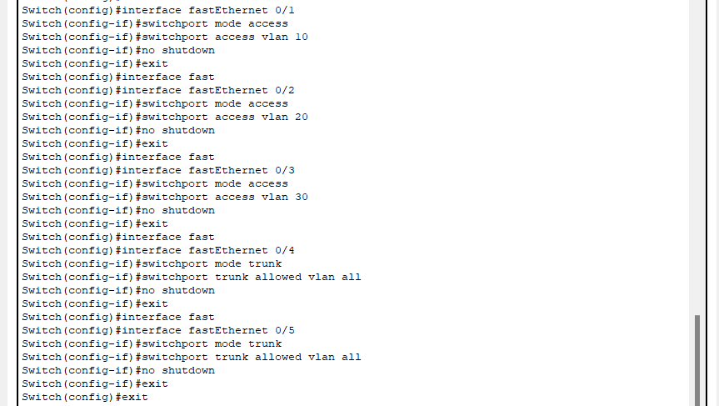

**For Switch 4:**

Same as Switch 2.

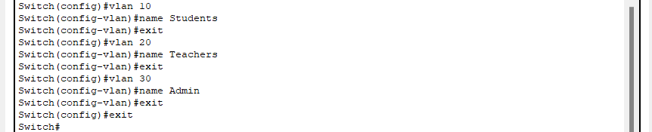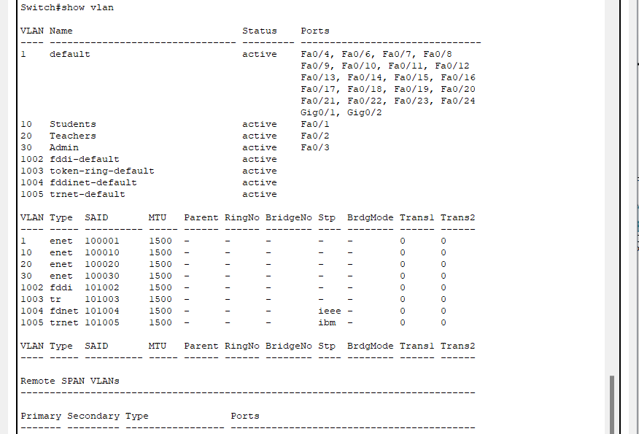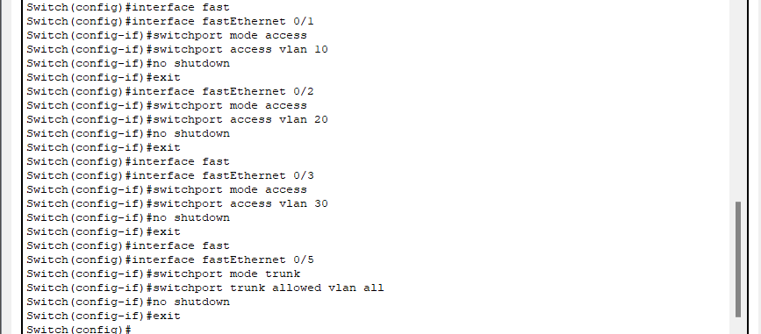

**From a PC of VLAN 10 to other PC of VLAN 10 and other VLANS:**

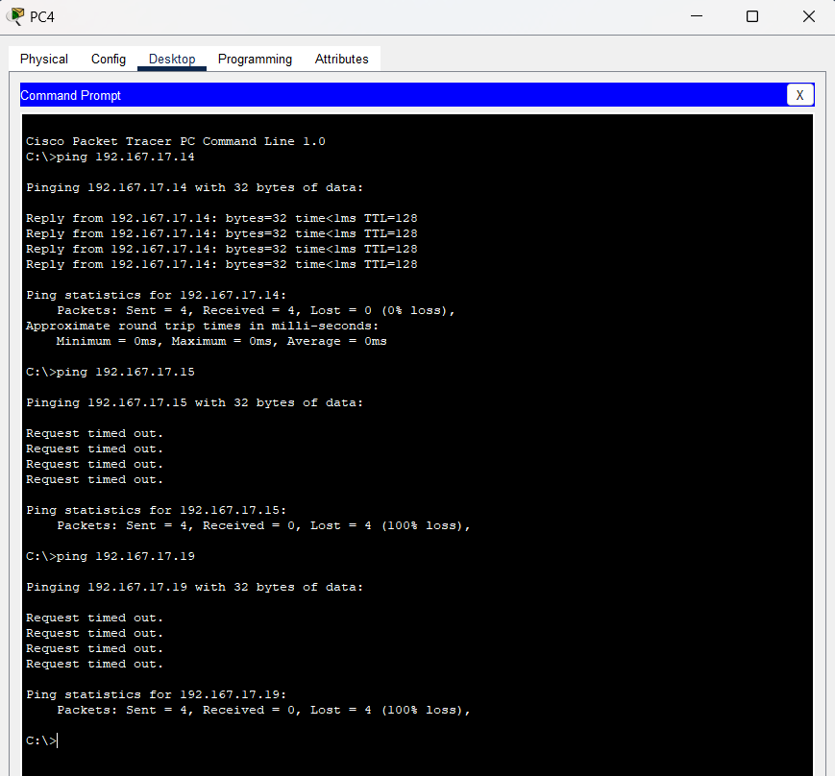

**From a PC of VLAN 20 to other PC of VLAN 20 and other VLANS:**

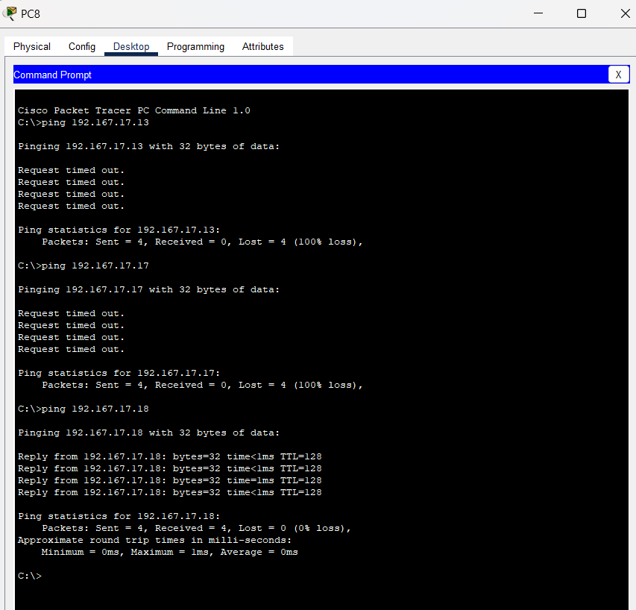

**From a PC of VLAN 30 to other PC of VLAN 30 and other VLANS:**

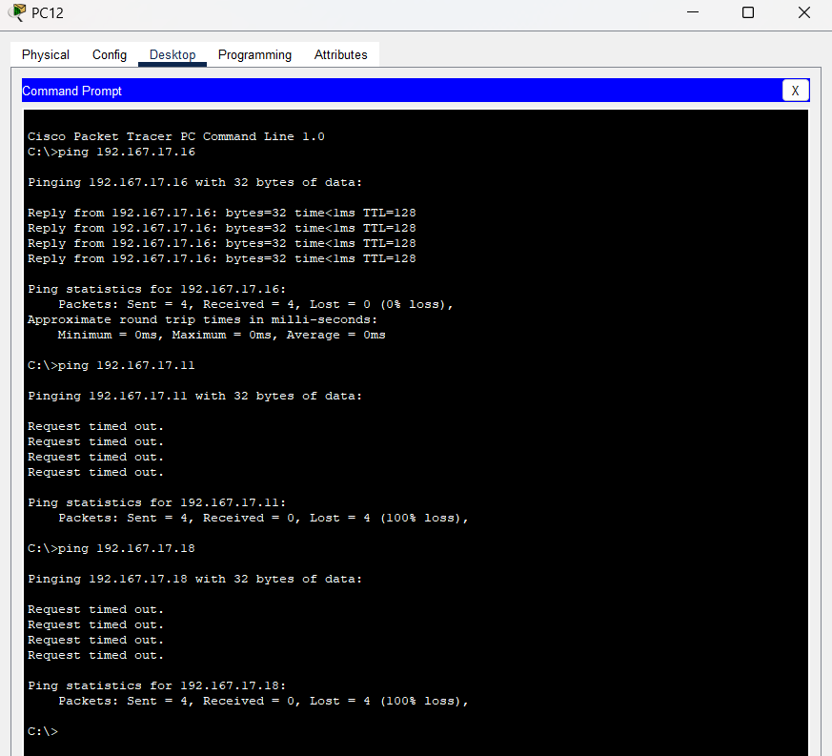

### **Questions (Answer to the point)**:

* + - 1. How many host bits are needed in the largest required subnet?

**Ans: example:**

**Let, host amount is 21. So the bits needed are 5 as 2^5=32 and 2^4=16.**

* + - 1. How many VLANs need to be configured to each of the switches?

**Ans: The amount of VLANs that are given.**

* + - 1. Which interfaces need Access Link?

**Ans: Ethernet ports**

* + - 1. Which interfaces need Trunk Link?

**Ans: Two switches or switch to router**

* + - 1. After configuring VLAN, what will happen if we broadcast?

**Ans: After configuring VLANs, broadcasts are confined to the specific VLAN, limiting their impact to devices within that VLAN.**

### **Challenges (if any):** It was kind of hard to keep track of all the configurations of the switches.

### 